

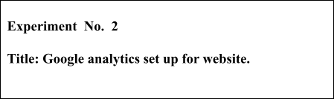

**Batch:B1 Roll No.: 1601421119 Experiment No.:2**

# Aim: Setting up Google Analytics for Website.

**--------------------------------------------------------------------------------------------**

**Resources needed:** Internet and MS-office

# Theory:

**GOOGLE ANALYTICS**

Knowing your audience and what they want is an important success factor for any website. The best way to know your audience is through your traffic stats and this is exactly what Google Analytics does. Google Analytics is one of the top, most powerful tools out there for monitoring and analysing traffic on your website. For using analytics one should create the account and then need to copy the tracking code. Once you add the tracking code to your webpages, Google analytics will track the various activities on the website and will generate the reports for it.

# Learning Extension Resources:



<https://www.youtube.com/watch?v=ZXSI5R7GeVA> (timestamp 0-2.58)

# Procedure:

1. Create account for Google Analytics .
2. Add basic page tracking to website by copying the code snippet.

# Results: (Stepwise procedure (with snapshots) for above question)

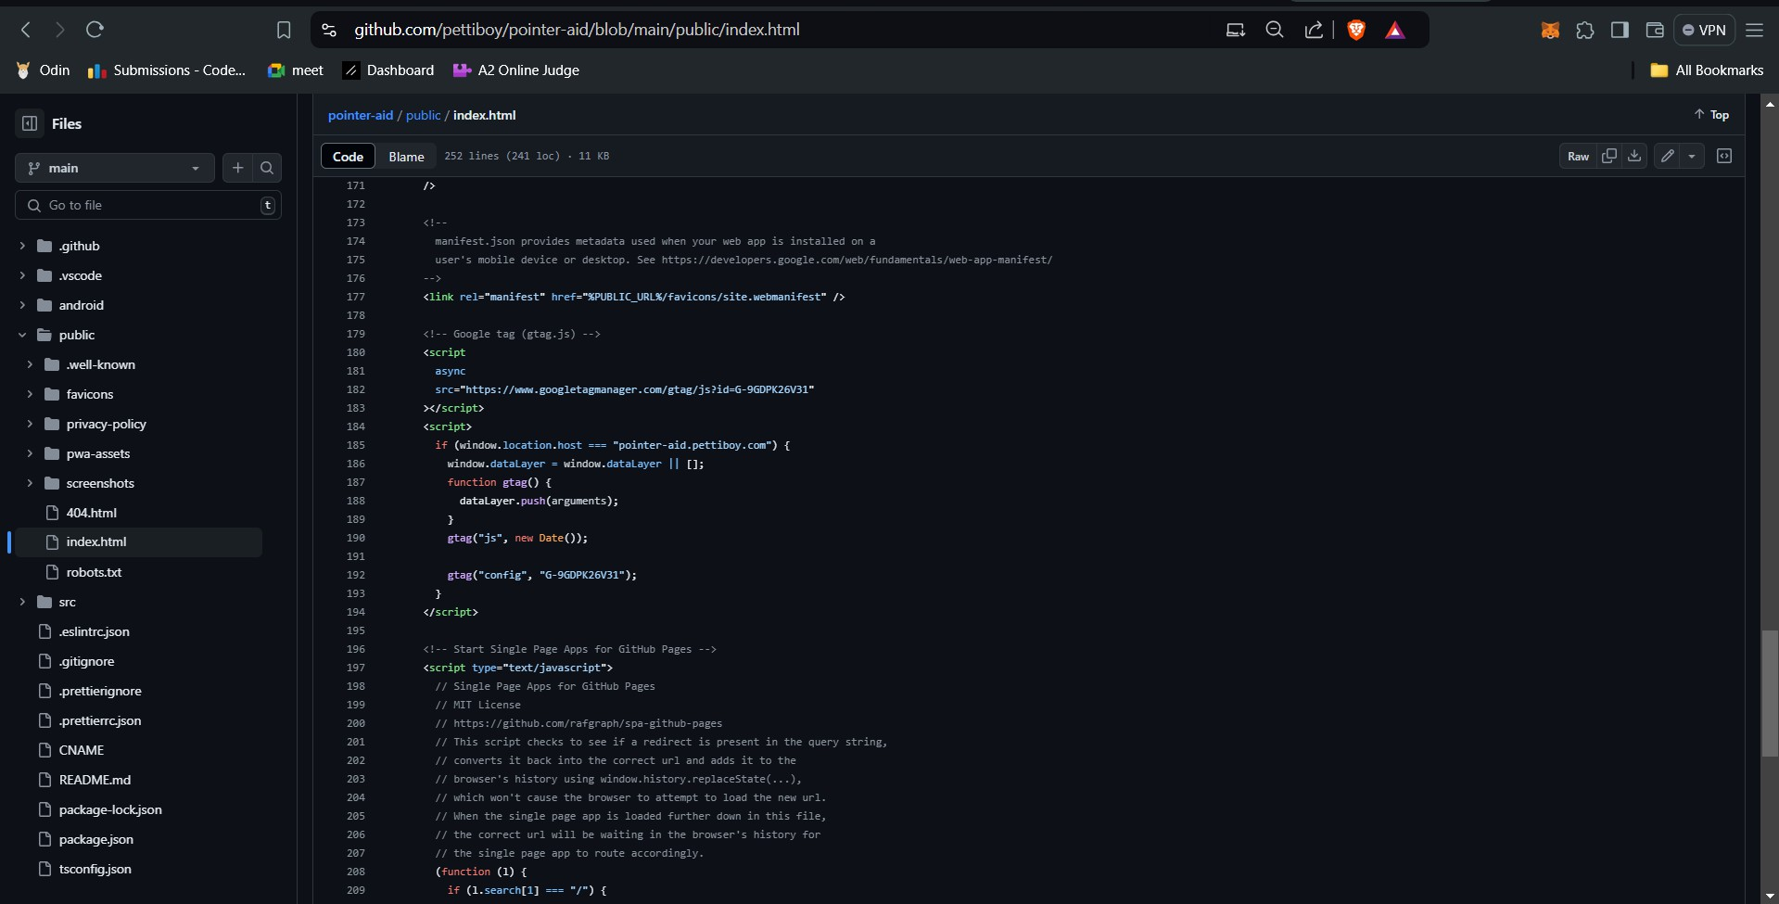



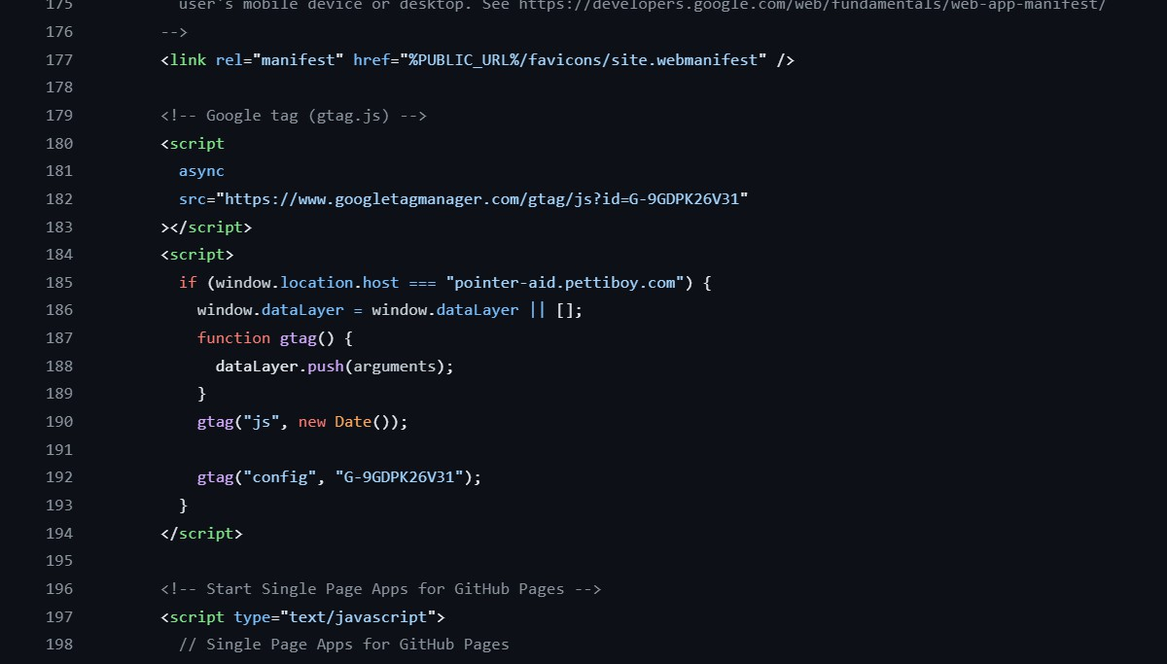

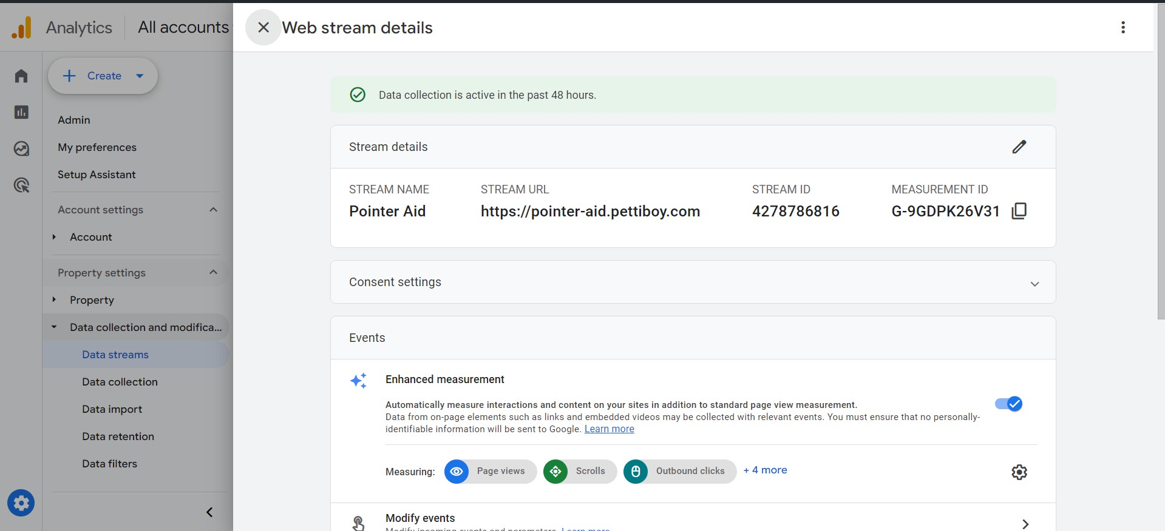

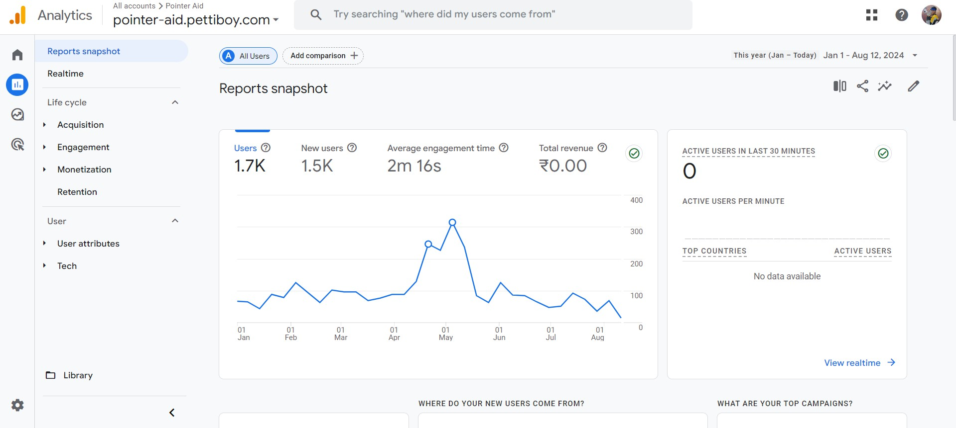

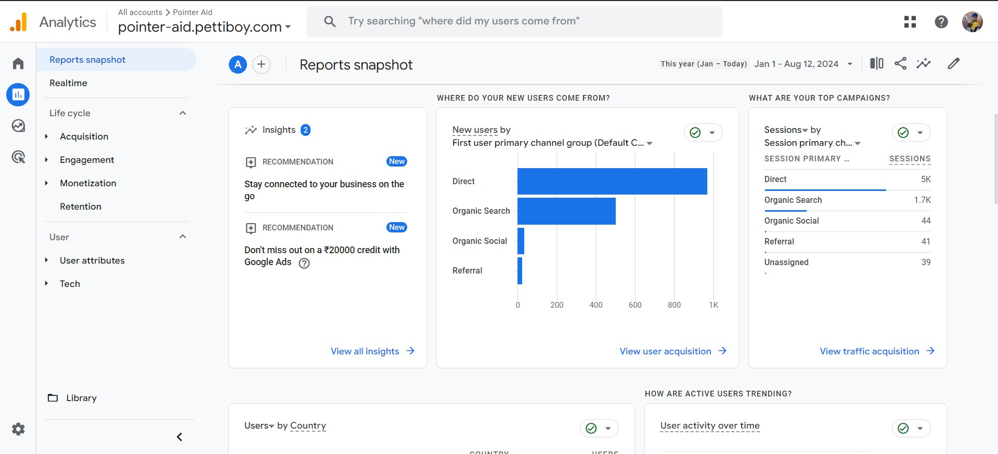

**Outcomes:** CO3 Prepare web site for web marketing and understanding SEO analytics



# Conclusion: (Conclusion to be based on the objectives and outcomes achieved)

implement and analyse the user data given by google analytics

**Grade: AA / AB / BB / BC / CC / CD /DD**

**Signature of faculty in-charge with date**

**References:**

1. Eric Enge, Stephan Spencer, Jessie Stricchiola, Rand Fishkin, “The Art of SEO, Mastering Search Engine Optimization”, O'Reilly Media; 2nd edition, 2012
2. John I Jerkovic, “SEO Warriors”, O'Reilly Media; 1st edition, 2009
3. RafiqElmansy, “Teach Yourself VISUALLY Search Engine Optimization (SEO)” John Wiley & Sons, 2013

